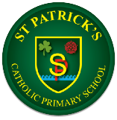
Geography
 | Autumn | Spring | Summer
Reception | Exploring maps | Outdoor activities | Around world
Year 1 | What is it like here? | What is the weather like in the UK? | What is it like to live in Shanghai?
Year 2 | Would you prefer to live in a hot or a cold place? | Why is our world wonderful? | What is it like to live by the coast?
Year 3 | Why do people live near volcanoes? | Who lives in Antarctica? | Are all settlements the same?
Year 4 | Why are rainforests important to us? | Where does out food come from? | What are rivers and how are they used?
Year 5 | What is life like in the Alps? | Why do oceans matter? | Would you like to live in the desert?
Year 6 | Why does population change? | Where does our energy come from? | Can I carry out independent fieldwork enquiry?

