St Patrick’s Catholic Primary School
The Catholic Diocese of Lancaster
Our Mission Statement:
“Sharing Our Faith, Inspiring Education, Achieving Our Dreams”

“Go, therefore, make disciples of all nations.
And look, I am with you always; yes, to the end of
time.” (Matthew 28:19-20)
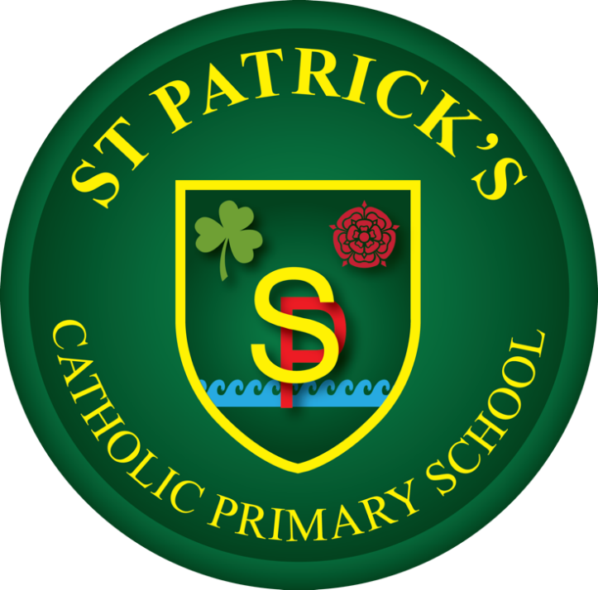

Art and Design Policy
At St Patrick’s Catholic Primary School, we celebrate that we are
all unique and loved by God. With Christ at the centre of all we
do, we strive to unlock each child’s potential to become the
individual they are created to be. We are working together to
build a community built on love, faith, forgiveness and service.

Approved by J. Murphy (Headteacher) Date: 22.06.26
Agreed in Principle June 2026
Approved by Governing Body/Committee: ___________ Date: _______
Next review date: October 2028
Art and Design Policy Statement
School Mission and Curriculum Intent
At St Patrick’s Catholic Primary School, our Art and Design curriculum is deeply rooted in our mission statement: "Sharing Our Faith, Inspiring Education and Achieving Our Dreams". Guided by this we view creativity as a profound gift from God. We believe that art offers children a unique language to explore their spirituality, celebrate the beauty of creation, and express their inner thoughts, feelings, and identities.
By adopting the Kapow Primary Art and Design scheme, our intent is to build a highly inclusive environment where every child feels confident to create, experiment, and reflect like an artist. We do not seek cookie-cutter outcomes; instead, we value the individual creative process, resilience through mistakes, and the growth of critical thinking.

Core Principles of Our Curriculum Design:
- The Sequential Spiral Model: Artistic skills, vocabulary, and techniques are introduced systematically and revisited with increasing complexity year-on-year to build authentic mastery.
- Process Over Product: The focus of our teaching is on the journey inside the sketchbook—experimenting, adapting, and taking creative risks—rather than solely focusing on a polished final piece.
- Diverse Cultural Representation: Our pupils study a carefully curated balance of classical masters, contemporary creators, and artists from highly diverse backgrounds, genders, and eras.

Statutory Framework and National Curriculum Strands
This policy ensures compliance with the National Curriculum Programme of Study for Art and Design (Key Stage 1 and Key Stage 2), as well as the Expressive Arts and Design framework within the Early Years Foundation Stage (EYFS). The Kapow Primary curriculum organizes artistic development across four fundamental strands:
1. Making Skills: Developing practical technical control over a wide variety of materials, tools, and processes.
2. Formal Elements: Building practical and theoretical understanding of Line, Shape, Colour, Form, Texture, Pattern, and Tone.
3. Knowledge of Artists: Exploring the history, context, and techniques of significant craft makers, designers, and artists.
4. Evaluating: Developing a critical vocabulary to analyse both their own work and the artwork of others constructively.

Delivery and Implementation Strategy
Art and Design is taught with equal weight alongside Design and Technology (DT). To allow for deep creative immersion, uninterrupted focus, and proper management of media, St Patrick’s utilizes a blocked topic delivery model.

Time Allocation: Art is taught across three designated half-terms per academic year, alternating with DT units. Each unit contains approximately six comprehensive lessons.

The Role of the Sketchbook: From Year 1 to Year 6, every pupil uses a high-quality sketchbook. The sketchbook is protected as a safe space for brainstorming, testing mediums, analysing artists, and practicing techniques. It is not a neat exercise book; it is a visual record of an artist's thoughts and trial processes.

Continuous Teacher Support: Teachers utilize Kapow's integrated, expert-led instructional videos to model advanced techniques (such as specific clay joins or printmaking pressures) accurately and confidently before lessons.

Whole-School Curriculum Map
The plain text list below outlines the sequential, progressive units specified by the Kapow Primary scheme, split by year group and term.

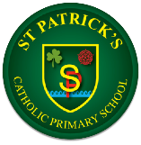
Art and Design
 | Autumn | Spring | Summer
Reception | DRAWING  marvellous me | PAINTING AND MIXED MEDIA  paint my world | SCULPTURE AND 3D  creation station
Year 1 | DRAWING  exploring line and shape | SCULPTURE AND 3D  paper play | PAINTING AND MIXED MEDIA  colour splash
Year 2 | DRAWING  understanding texture and tone | PAINTING AND MIXED MEDIA  life in colour | SCULPTURE AND 3D  clay houses
Year 3 | DRAWING  developing drawing skills | CRAFT AND DESIGN  ancient Egyptian scrolls | SCULPTURE AND 3D  abstract shape and space
Year 4 | DRAWING  exploring tone, texture and proportion | PAINTING AND MIXED MEDIA  light and dark | CRAFT AND DESIGN  fabric of nature
Year 5 | SCULPTURE AND 3D  interactive installation | DRAWING  depth, emotion and movement | PAINTING AND MIXED MEDIA  portraits
Year 6 | CRAFT AND DESIGN  photo opportunity | DRAWING  exploring ideas | SCULPTURE AND 3D  making memories

Inclusion, SEND, and Adaptive Practice
At St Patrick’s, we firmly believe there are no barriers to artistic expression. The Kapow Primary Art curriculum is inherently flexible, and lessons are adapted dynamically by our teachers to ensure all pupils, including those with Special Educational Needs and Disabilities (SEND), thrive.
* Physical Adaptations: We provide specialized tools such as easy-grip paintbrushes, double-loop scissors, sensory-friendly modelling clays, and table-top easels.
* Process Modifications: Lessons focus on exploration rather than a prescriptive end design. Tasks can be scaffolded by altering scales (e.g., drawing on large sugar paper on the floor for pupils with fine-motor challenges).
* Celebrating Neurodiversity: Visual arts offer a powerful alternative communication pathway. We actively celebrate non-verbal, abstract, and highly unique interpretations of tasks, ensuring every child’s voice is validated.

Assessment, Feedback, and Celebration
Assessment in Art and Design is supportive, formative, and focused on individual progression rather than arbitrary grading metrics.
- Verbal Feedback: Teachers deliver immediate, constructive feedback "live" during the creative process, helping pupils solve technical issues or refine a technique on the spot.
- Peer and Self-Reflection: Children are taught to evaluate their own work against the unit criteria within their sketchbooks, using kind, specific, and helpful artistic terminology.
- Progress Evidence: Progress is captured through the physical evolution of skills in sketchbooks and photographic records of temporary installations or 3D sculptures.
- Display and Celebration: To honour the artistic efforts of our children, high-quality, professional displays of pupil work are maintained in common areas, and digital galleries are shared regularly with our school families.

