St Patrick’s Catholic Primary School
The Catholic Diocese of Lancaster
Our Mission Statement:
“Sharing Our Faith, Inspiring Education, Achieving Our Dreams”

“Go, therefore, make disciples of all nations.
And look, I am with you always; yes, to the end of
time.” (Matthew 28:19-20)
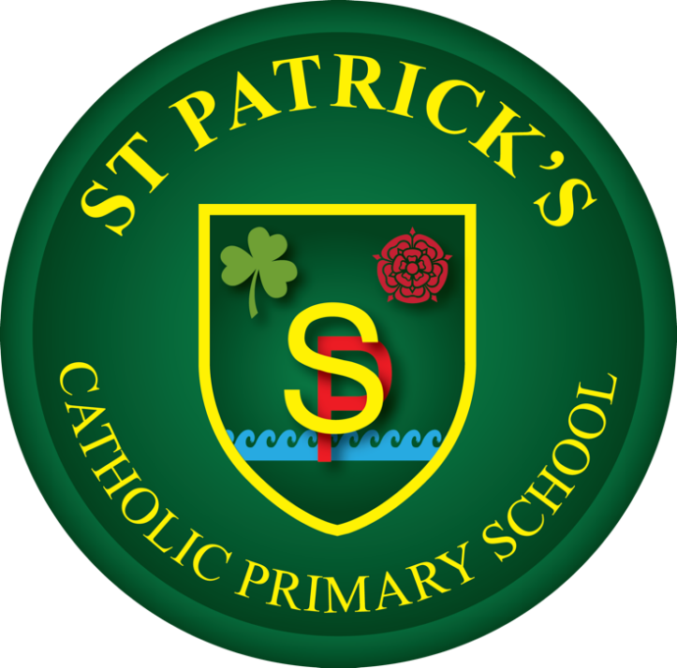

Geography Policy
At St Patrick’s Catholic Primary School, we celebrate that we are
all unique and loved by God. With Christ at the centre of all we
do, we strive to unlock each child’s potential to become the
individual they are created to be. We are working together to
build a community built on love, faith, forgiveness and service.

Approved by J. Murphy (Headteacher) Date: 22.06.2026
Agreed in Principle June 2026
Approved by Governing Body/Committee: ___________ Date: _______
Next review date: October 2028
Geography Policy Statement

The Geography curriculum at our school is built on the belief that every child should be inspired to become a curious and explorative thinker with a diverse knowledge of the world. Our primary aim is to teach children to "think like geographers" by giving them the confidence to question the world around them, observe physical and human patterns, and measure and record data using a variety of methods. By analysing and presenting their findings, pupils develop a deep understanding of how geography shapes lives across different timescales and at multiple scales, from their local community to the wider world.
We aim to nurture resourceful, active citizens who possess the skills and desire to contribute to and improve the environment around them. To achieve this, we utilize the Kapow Primary Geography scheme, which is specifically designed to support our teachers in developing their own subject knowledge. This ensures the delivery of well-informed, engaging lessons that are both accessible to every child and ambitious enough to push them toward their full potential.
Central to our approach is a spiral curriculum model. This means that instead of teaching topics in isolation, we ensure children revisit and develop their understanding of key themes and concepts as they progress through the school. This regular exposure strengthens memory and prevents knowledge from being forgotten, allowing pupils to make meaningful connections between different areas of learning. As concepts are revisited, they are expanded upon with progressive depth, helping pupils refine their skills in new and more complex contexts.
This adaptive way of learning ensures we meet every pupil at their current level, providing extra reinforcement where needed and offering greater challenges to those ready to move ahead. Progress is captured through a diverse range of evidence, moving beyond simple testing to include structured written work, detailed annotated diagrams, and creative responses. Through this consistent and connected journey, our pupils achieve true mastery of the subject, leaving our school with a rich, lasting understanding of the world they inhabit.

School Mission and Curriculum Intent
At St Patrick’s Catholic Primary School, our Geography curriculum is deeply rooted in our mission statement: "Sharing Our Faith, Inspiring Education and Achieving Our Dreams". Guided by our mission statement we teach our children to look at the world around them with a sense of wonder, respect, and stewardship. We recognize the Earth as God’s creation and seek to develop responsible, global citizens who appreciate the interconnectedness of human choices and the natural physical environment.
By adopting the Kapow Primary Geography scheme, our intent is to inspire pupils to become curious, critical, and explorative thinkers—to think like a geographer. We want our children to possess a diverse knowledge of the world, gaining the confidence to question, observe, measure, record, and present findings regarding their local environment of Heysham and the wider global community.

Core Principles of Our Curriculum Design:
The Spiral Model: The Kapow scheme is structured as a spiral curriculum where essential knowledge and skills are systematically revisited with increasing complexity, ensuring long-term retrieval and deeper mastery.
Enquiry-Led Learning: Geography is framed around a clear enquiry cycle: Question, Observe, Measure, Record, and Present.
Locality as a Launchpad: We deliberately ground foundational mapping and fieldwork concepts within Heysham, Morecambe Bay, and the Lancashire coastal landscape before scaling out to national and global contexts.

Statutory Framework and National Curriculum Strands
This policy ensures compliance with the statutory National Curriculum Programme of Study for Key Stage 1 and Key Stage 2, as well as the Early Years Foundation Stage (EYFS) Development Matters framework. The Kapow Primary curriculum organises geographical learning into four core structural strands:
1. Locational Knowledge: Naming and identifying major global components, continents, oceans, countries, regions, and cities.
2. Place Knowledge: Developing a deep understanding of geographical similarities and differences through comparative studies of contrasting human and physical environments.
3. Human and Physical Geography: Exploring natural processes (weather, climate, biomes, tectonic activity, water cycle) alongside human processes (settlements, land use, economic activity, resource distribution).
4. Geographical Skills and Fieldwork: Practising map work, digital mapping, compass orientation, grid reading, data collection, and physical environmental analysis out in the field.

Delivery and Implementation Strategy
Geography is allocated equitable learning time alongside History. To ensure immersion, deep focus, and high-quality retrieval, St Patrick’s implements a blocked topic delivery model.
Geography is taught across three designated half-terms per academic year, alternating with History units. Each unit contains approximately six comprehensive lessons.
While following Kapow's long-term plan, teachers deliberately thread our unique coastal landscape into the learning—utilising Morecambe Bay, local nuclear power infrastructures, and Heysham Port to contextualise physical geography, industry, and environmental sustainability units.
Kapow's built-in teacher video guides, subject-expert animations, and Knowledge Organisers are utilized directly by teaching staff to ensure robust subject knowledge before launching any unit.

Whole-School Curriculum Map
The table below outlines the sequential, progressive units specified by the Kapow Primary scheme, ensuring complete coverage from Early Years through to Year 6.

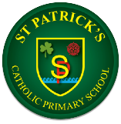
Geography
 | Autumn | Spring | Summer
Reception | Exploring maps | Outdoor activities | Around world
Year 1 | What is it like here? | What is the weather like in the UK? | What is it like to live in Shanghai?
Year 2 | Would you prefer to live in a hot or a cold place? | Why is our world wonderful? | What is it like to live by the coast?
Year 3 | Why do people live near volcanoes? | Who lives in Antarctica? | Are all settlements the same?
Year 4 | Why are rainforests important to us? | Where does out food come from? | What are rivers and how are they used?
Year 5 | What is life like in the Alps? | Why do oceans matter? | Would you like to live in the desert?
Year 6 | Why does population change? | Where does our energy come from? | Can I carry out independent fieldwork enquiry?

Fieldwork and Outdoor Learning
Fieldwork is an essential statutory requirement of the National Curriculum and is centrally embedded within every single year group’s Kapow unit sequence. Fieldwork follows an active, practical approach and is not confined solely to textbook exercises.
- The Immediate Environment: Pupils regularly utilize our school grounds, playing fields, and immediate parish boundary to build foundational surveying, sketches, and tracking habits.
- The Heysham Locality: As pupils progress, fieldwork journeys move out into the Heysham village, checking land use patterns at the local port, taking beach profiles at the coast, and measuring environmental impacts near our local green spaces.
- Data Tool Integration: Children utilize physical measuring equipment (anemometers, trundle wheels, traditional compasses) alongside modern digital mapping technologies (Digimap for Schools, Google Earth Pro) to capture, evaluate, and interpret geographical data sets.

Inclusion, SEND, and Differentiation
At St Patrick’s, we aim for every child to access an ambitious curriculum, adapting teaching techniques to ensure high-quality learning for pupils with Special Educational Needs and Disabilities (SEND). Kapow’s adaptable lesson design allows our teachers to support all learners effectively without lowering expectations.
Visual and Tactical Scaffolding: Lessons use highly visual slide packages, multi-sensory map work, 3D landform models, and clearly demarcated Knowledge Organisers.
Alternative Recording: Pupils who experience barriers with extended writing can evidence their geographic understanding using annotated diagrams, voice recordings, drag-and-drop digital mapping tools, or videoed presentations of data.
Adult Support and Grouping: Fieldwork and collaborative tasks are carefully scaffolded with adult intervention, paired working, and varied grouping strategies to enhance equity of access.

Assessment, Tracking, and Progress Record
We utilize a comprehensive, two-fold assessment strategy provided within the Kapow framework to measure impact accurately while remaining free from unnecessary workload burdens.

Formative Assessment (Assessment for Learning)
Live Assessment: Teachers monitor real-time class dialogue, map execution, and precision during the enquiry process. Each individual Kapow lesson plan contains explicit target criteria to measure learning success indicators directly on the spot.
Knowledge Catcher: Used at the opening phase of a unit to record baseline operational knowledge and revisited dynamically to evaluate incoming facts.

Summative Assessment
Unit Quizzes: Implemented at the closing of each geographical topic to evaluate retention of core geographical vocabulary, locational facts, and conceptual understanding.
Evidence Portfolios: Progress is evidenced via specialized foundation stage books or individual pupil geography books containing map work, field data reports, and knowledge organizers.
Subject tracking data is logged into our school’s internal reporting system termly, identifying children who are working *towards*, *meeting*, or *exceeding* age-related National Curriculum expectations.

