St Patrick’s Catholic Primary School
The Catholic Diocese of Lancaster
Our Mission Statement:
“Sharing Our Faith, Inspiring Education, Achieving Our Dreams”

“Go, therefore, make disciples of all nations.
And look, I am with you always; yes, to the end of
time.” (Matthew 28:19-20)
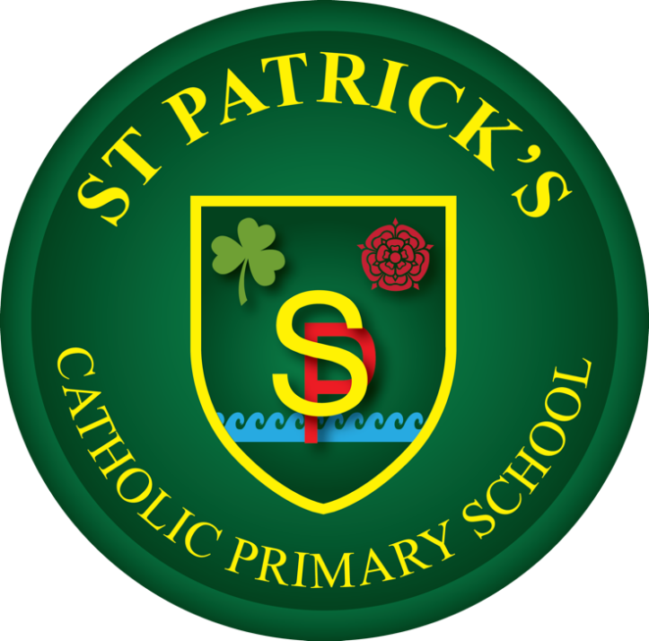

History Policy
At St Patrick’s Catholic Primary School, we celebrate that we are
all unique and loved by God. With Christ at the centre of all we
do, we strive to unlock each child’s potential to become the
individual they are created to be. We are working together to
build a community built on love, faith, forgiveness and service.

Approved by J. Murphy (Headteacher) Date: 22.06.2026
Agreed in Principle June 2026
Approved by Governing Body/Committee: ___________ Date: _______
Next review date: October 2028
History Policy Statement
School Mission and Curriculum Vision
At St Patrick’s Catholic Primary School, we celebrate that we are all unique and loved by God. With Christ at the centre of all we do, we strive to unlock each child’s potential to become the individual they are created to be. We are working together to build a community built on love, faith, forgiveness and service, deeply rooted in our mission statement: "Sharing Our Faith, Inspiring Education, Achieving Our Dreams". Guided by the Gospel directive to go forth and make disciples, we teach our children to look at the human journey through time with empathy, respect, and a desire to seek truth.

At St Patrick’s Catholic Primary School, we believe that history should inspire pupils to become curious, reflective and analytical thinkers. Through a high-quality, knowledge-rich curriculum, we aim to develop pupils’ understanding of Britain’s past and the wider world, enabling them to appreciate how historical events have shaped modern society.
Our history curriculum is designed to provide pupils with a secure understanding of significant events, people and periods, while fostering a sense of curiosity about the past. We aim to equip all pupils with the skills of a historian, enabling them to ask perceptive questions, think critically, evaluate evidence and develop informed judgements about historical events and their significance. Through the study of history, pupils gain an understanding of chronology, cause and consequence, change and continuity, and historical significance, preparing them to become informed and responsible citizens.

Statutory Framework and Curriculum Design
This policy ensures compliance with the statutory National Curriculum Programme of Study for History (Key Stage 1 and Key Stage 2), as well as the "Understanding the World" specific area within the Early Years Foundation Stage (EYFS) Framework.
Our history curriculum is supported by the Kapow Primary scheme of work, which provides a carefully sequenced and progressive programme of study. Pupils study three history units within each academic year, with each unit lasting for one half term, alternating in a blocked model with Geography. Learning is structured to ensure the systematic development of both substantive knowledge (historical facts, concepts and content) and disciplinary knowledge (the methods and skills used by historians).

Enquiry-Led Framework
Each unit begins with a carefully considered enquiry question that provides a clear purpose for learning and promotes curiosity. These questions guide learning throughout the unit, encouraging pupils to make connections between historical concepts and apply their understanding in meaningful ways. Final outcomes frequently return to the original enquiry question, enabling pupils to demonstrate and reflect upon their learning.
Our adoption of a spiral curriculum model aims to strengthen understanding, improve retention and enable pupils to make connections between different areas of learning. As learning is revisited, it is developed in greater depth, allowing pupils to build on prior knowledge and apply their understanding in increasingly challenging contexts.

Teaching and Learning Implementation
History lessons are designed to be engaging, interactive and inclusive. New knowledge is introduced in manageable steps through effective teacher explanations, storytelling, discussion and the use of high-quality visual resources. Teachers explicitly model historical thinking and regularly revisit key concepts to deepen understanding.

Classroom Strategies:
- Retrieval Activities: Lessons typically begin with retrieval activities to reinforce prior learning and strengthen long-term memory.
- Historical Reasoning: Pupils are provided with opportunities to develop their historical reasoning through discussion, debate, role-play and collaborative learning activities. These approaches encourage pupils to articulate their ideas, challenge viewpoints and justify their thinking using evidence.
- Sources and Artefacts: A wide range of historical sources and artefacts, including photographs, written documents, videos and physical artefacts, are used to support learning. Additional resources are accessed through the Lancashire Heritage Learning Service, further enriching the curriculum.
- Experiential Learning: Educational visits and historical experiences enhance pupils’ understanding and bring learning to life. Where appropriate, local history connections leverage Heysham’s heritage, such as St Patrick's Chapel ruins, to contextualize national changes.

Whole-School Curriculum Map
The table below outlines the sequential, progressive units specified by the Kapow Primary scheme, ensuring complete coverage across all terms.
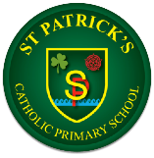
History
 | Autumn | Spring | Summer
Reception |  | Peek into the past | Adventures through time
Year 1 | How am I making history? | How have toys changed? | How have explorers changed the world?
Year 2 | How was school different in the past? | How did we learn to fly? | What is a monarch?
Year 3 | Would you prefer to live in the Stone Age, Iron Age, or Bronze Age? | Why did the Romans invade and settle in Britain? | What did the Ancient Egyptians believe?
Year 4 | How have children’s lives changed? | How hard was it to invade and settle in Britain? | How did the achievements of the Maya Civilisation influence their society and beyond?
Year 5 | Were the Vikings raiders, traders or something else? | What was life like in Tudor England? | What did the Greeks do for us?
Year 6 | What can the Census tell us about local areas? | What was the impact of World War 2 on Britain? | Unheard histories; who should go on the bank note?

Inclusion, SEND, and Adaptive Teaching
At St Patrick’s, teaching is adapted to meet the needs of all pupils, providing support where needed and challenge for those ready to deepen their learning. Adaptive teaching strategies ensure that all pupils, including those with SEND, can access and succeed within the curriculum. Appropriate scaffolding, targeted support and carefully planned resources enable all learners to participate fully and make progress.
- Scaffolded Reasoning: Visual timelines, dual-coded vocabulary banks, and structured writing frames are utilized to reduce cognitive load during complex source evaluation.
- Flexible Recording: Pupils are provided with opportunities to capture historical understanding through annotated sketches, verbal presentations, timeline sorting activities, or collaborative digital presentations, ensuring that literacy boundaries do not mask historical competency.

Assessment, Tracking, and Outcomes for Pupils
Through the study of history at St Patrick’s, pupils develop:
- A secure knowledge and understanding of significant local, national and global historical events, people and periods.
- A strong understanding of chronology and how different periods of history are connected.
- An increasingly sophisticated historical vocabulary that can be applied confidently in discussion and written work.
- The ability to think critically, ask questions, evaluate evidence and draw informed conclusions.
- A secure understanding of key historical concepts, including cause and consequence, change and continuity, and historical significance.
- The confidence to communicate historical knowledge and justify opinions using evidence.
- A genuine curiosity about the past and a sustained enthusiasm for learning history.

Assessment Framework
Assessment is ongoing and embedded throughout each unit. Teachers use questioning, retrieval quizzes, discussion, practical tasks, and end-of-lesson or topic mini quizzes to monitor understanding, identify misconceptions, measure progress, and plan next steps effectively. This comprehensive approach allows teachers to track pupil performance into our school tracking system, ensuring all children leave St Patrick’s with the knowledge, skills and understanding necessary to appreciate the influence of the past on the world around them.

