St Patrick’s Catholic Primary School
The Catholic Diocese of Lancaster
Our Mission Statement:
“Sharing Our Faith, Inspiring Education, Achieving Our Dreams”

“Go, therefore, make disciples of all nations.
And look, I am with you always; yes, to the end of
time.” (Matthew 28:19-20)
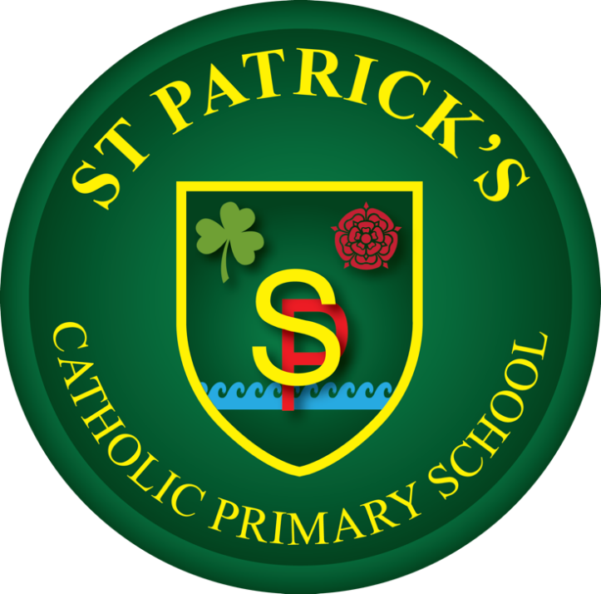

Music Policy
At St Patrick’s Catholic Primary School, we celebrate that we are
all unique and loved by God. With Christ at the centre of all we
do, we strive to unlock each child’s potential to become the
individual they are created to be. We are working together to
build a community built on love, faith, forgiveness and service.

Approved by J. Murphy (Headteacher) Date: 22.06.2026
Agreed in Principle June 2026
Approved by Governing Body/Committee: ___________ Date: _______
Next review date: October 2028
St Patrick’s Catholic Primary School Languages (FL) Policy
Policy leader: Bethan Slater
Our vision
At our school, the intent of the Music curriculum is to inspire pupils to develop a lifelong love and appreciation of music, while providing opportunities for creativity, self-expression and spiritual development. In line with our Catholic ethos, music plays a key role in worship and celebration, allowing pupils to reflect, participate and contribute meaningfully to the life of the school.
The teaching of music is designed to provide pupils with a broad and balanced education, enabling them to listen, perform, compose and evaluate music across a range of styles, genres and cultural traditions. Through this, pupils develop not only their musical knowledge and skills, but also wider transferable skills such as confidence, collaboration, discipline and resilience.
Our curriculum is carefully sequenced to ensure that pupils build on prior learning over time. Pupils develop substantive knowledge (such as rhythm, pitch, tempo and dynamics) alongside disciplinary knowledge (understanding how music is created, performed and interpreted). Pupils are encouraged to explore and appreciate music from different cultures and historical periods, supporting a deeper understanding of both music and the wider world.
We recognise that music is a powerful form of communication and expression. It contributes significantly to pupils’ personal development and wellbeing, while fostering a sense of belonging and identity. Through our music curriculum, we aim to ensure that all pupils have access to high-quality musical experiences and are equipped with the knowledge and confidence to continue their musical journey beyond primary school.

How we learn
Music is taught across all year groups as part of a planned and progressive curriculum. Our expectation is that music is delivered consistently to a high standard, ensuring that pupils develop their musical knowledge and skills over time. Through monitoring, including lesson observations and review of outcomes, we ensure that pupils make sustained progress in all aspects of music.
All staff delivering music are expected to do so with clarity, enthusiasm and confidence, modelling good practice and fostering a positive and inclusive environment. This supports pupils’ engagement and encourages active participation in musical activities.
Teaching is structured to ensure pupils have regular opportunities to develop skills across the key areas of musical learning: listening, performing, composing and appraising. A range of approaches are used to support this, including:
- Practical music-making through singing, instrument playing and movement
- Listening to and appraising a wide range of music from different cultures and traditions
- Composing and improvising using voices, instruments and digital tools
- The use of structured activities to develop understanding of musical elements such as rhythm, pitch and dynamics
- Opportunities for collaborative learning, including group performances and ensemble work
- Positive reinforcement and encouragement to build confidence and participation
Music is also embedded across the wider curriculum and school life, including collective worship, liturgical celebrations and performances, ensuring pupils experience the purpose and value of music in meaningful contexts.

The result
By the end of Year 2 pupils will have:
- Developed an awareness of music through listening, singing and playing
- Begun to understand basic musical elements such as pulse and rhythm
- Participated in simple performances and developed confidence in sharing music
By the end of Year 4 pupils will have been taught:
- To perform using voices and instruments with increasing accuracy and control
- To listen to and identify key musical features such as tempo, dynamics and structure
- To compose and organise musical ideas using simple patterns and structures
- To read and begin to use basic musical notation
By the end of Year 6 pupils will have an awareness of and experience of:
- Performing confidently as part of a group or independently with control and expression
- Understanding a broader range of musical elements, including harmony and structure
- Composing music for a purpose, using appropriate musical vocabulary and notation
- Listening critically to a wide range of music, analysing and evaluating its features
- Appreciating music from different cultures, traditions and historical periods

Inclusion
At our school, all pupils are entitled to experience a rich music curriculum. We ensure that learning opportunities are inclusive and accessible, enabling all pupils to develop their musical skills and confidence. As part of our commitment to providing a broad and balanced curriculum, all children are given opportunities to participate fully in musical learning regardless of ability or background.
Teachers provide appropriate support and challenge to ensure that all pupils make progress. This may include adapting tasks, providing additional scaffolding or offering opportunities for greater depth. Pupils are encouraged to express themselves creatively and take risks in a supportive environment.

