

St Patrick’s Catholic Primary School
Human Relationships and Sex Education Policy
Revised October 2026

Preface
In the Gospels we can observe two beautiful aspects of Jesus’ character. On one hand, he is profoundly open to those on the margins of the society of the time - Gentiles, Samaritans, women and the poor; the blind, the sick and the lame; tax collectors and prostitutes. We see in his association with them a beautiful portrayal of God’s overflowing love.
At the same time, equally attractive is the fact that he maintained his integrity perfectly. He did not compromise his cultural identity, was morally flawless and he spoke with clarity and authority to all about the true demands of God’s law, calling people both to repentance and deeper obedience.
We might expect his integrity to have been a barrier to his friendship with the marginalised, but it was not. On the contrary, it was precisely this that enabled him to show God’s love so clearly and share it in a way that not only showed affection but also brought transformation and salvation.
In this pattern, we see something like hospitality at work. Jesus maintains his relationship with God the Father, a “house” to invite people into. At the same time, he truly welcomes people into it so they can begin to experience the love of God and love him in return. By this, people are saved, healed and transformed into saints.
The Church reflects this hospitality in her mission. She is described in Scripture as a walled city with gates that are always open. She sees all that is good in the world and welcomes it in, and in doing so she pours forth light, life and healing to the world.
The Catholic identity of our schools depends on us matching this character of Christ and his Church. If we can follow Christ’s example in this way, our schools can be communities of real, mutual communion which are enriched by all that our pupils have to offer, and which fully and persuasively offer the saving and fulfilling truth of God’s design for our lives.
This is especially important for HRSE. This is because the teaching of the Church on these topics is so impactful and so urgently needed. In addition, it is because Catholic doctrine can sometimes be perceived to be at odds with attitudes in wider society. In our cultural context and the lives of our pupils, the Church recognises valuable resources for deepening our understanding of Christ and the furtherance of the Church’s mission. Thus, it is that in HRSE we need clear expression, and effective implementation, of this culture of integrity and dialogue.
The following policy aims to support this goal. Our hope is that through our schools we can welcome all into the house of the Father, so that they might know Him as they are known, and live lives full of His grace.

Human Relationships and
Sex Education Policy for St Patrick’s Catholic Primary School

Key Information
Policy Title | Human Relationships and Sex Education (HRSE) Policy
Version Number | 1
Date of Approval | October 2026
Approved by | Governing Body of St Patrick’s Catholic Primary School
Implementation Date | Implementation of the policy will take place after consultation with the Governors in the Autumn term 2026.
Review Date | Autumn 2028
Policy Statement | Human Relationships and Sex Education (HRSE) is provided by this school as part of the mission of the Catholic Church. HRSE is delivered in a manner consistent with that mission: it seeks to shape the whole person through virtues and values, is conducted through dialogue, is exercised with prudent judgement appropriate to the age, maturity and needs of pupils, and is directed positively towards happiness and human flourishing. HRSE is taught in unity with the Catholic Church under the pastoral oversight of the Bishop of Lancaster, is delivered in partnership with parents as the primary educators of their children, is overseen by the governing body on behalf of the Bishop, and fulfils the statutory requirements for Relationships [and Sex Education] and Health Education.
Principle Officers | Julie Murphy – Headteacher
Consultation | [Summarise Section 4.9 Consultation]
Diocesan Oversight | A copy of this policy was submitted to the Diocese of Lancaster Education Service for episcopal oversight on [insert date] via email to Heather Watts (Diocesan Officer)
Key Information for Parents | - Parents are recognised as the primary educators of their children (see Section 3.2).  - All curriculum content and resources are available to parents on request.  For full details of how to request access please see Section 4.10.  - Parents have the right to request withdrawal from non-statutory sex education (see Section 4.4.5).  - Sex Education is not part of the HRSE curriculum in our school.  - Questions or concerns about HRSE can be raised through the process set out in Section 4.1.4 or via the school’s Complaints Policy.

Rationale & Purpose of This Policy Document
Schools must maintain and publish a written policy for Relationships [Sex] and Health Education to ensure transparency, consistency, and accountability in its delivery. Statutory guidance issued by the Department for Education requires schools to make clear their approach to Relationships [Sex] and Health Education so that parents, governors, and other stakeholders can understand the provision.
This policy is therefore required in order to fulfil the legal duties set out in the Children and Social Work Act 2017 and the Relationships Education, Relationships and Sex Education and Health Education (England) Regulations, together with the Department for Education statutory guidance updated July 2025 (for implementation from September 2026), as well as to support safeguarding obligations, promote equality of opportunity under the Equality Act 2010, and prepare pupils for life in modern society.
Moreover, because of the significance of the topics involved, the need for prudence in delivery, and the opportunities afforded by Catholic Schools, the Bishop of Lancaster requires that Catholic schools provide a clear and accountable policy for this same provision to ensure transparency and fidelity to the Church’s teaching and mission.
The Church, through the Bishop, has the responsibility to oversee the content and manner of this formation, ensuring that it reflects the Church’s moral and theological vision.
A public statement of the school’s approach enables all stakeholders, especially Catholic stakeholders, including parents, pupils and staff, foundation governors and the Bishop and his representatives to support the school in its witness to the faith and its role in the Church’s mission of evangelisation.
The purpose of this policy document is to:
- set out the aims and principles that govern the school’s provision of HRSE;
- define the content, scope, and boundaries of HRSE provision within the curriculum;
- specify the responsibilities, methods, and review processes by which HRSE is planned, delivered, and evaluated;
- provide transparency and accountability to governors, parents, and the wider community;
- uphold parents’ legal rights, including the right to request withdrawal from sex education in secondary schools;
- support compliance with safeguarding obligations and equality duties under the Equality Act 2010;
- articulate how the school’s HRSE provision aligns with the moral and theological teaching of the Catholic Church and is exercised under episcopal oversight;
- provide a clear and shared framework through which Catholic parents, pupils, staff, foundation governors, diocesan representatives, and the wider Catholic community can understand and support the school’s distinctive approach;
- set out how HRSE provision participates in the holistic formation of pupils;
- ensure consistency and transparency in the expression and safeguarding of Catholic teaching and identity within HRSE;
- clarify how the school works in partnership with parents as the primary educators of their children in matters of human love, relationships, and sexuality.

Policy Statement
Human Relationships and Sex Education (HRSE) is provided by this school as part of the mission of the Catholic Church. HRSE is delivered in a manner consistent with that mission: it seeks to shape the whole person through virtues and values, is conducted through dialogue, is exercised with prudent judgement appropriate to the age, maturity and needs of pupils, and is directed positively towards happiness and human flourishing. HRSE is taught in unity with the Catholic Church under the pastoral oversight of the Bishop of Lancaster, is delivered in partnership with parents as the primary educators of their children, is overseen by the governing body on behalf of the Bishop, and fulfils the statutory requirements for Relationships and Health Education.

HRSE at St Patrick’s Catholic Primary School
This section is the core of the policy document. It explains how HRSE is organised, delivered and evaluated in the school so that all obligations and expectations are met in one coherent framework.
Throughout this section the Catholic term Human Relationships and Sex Education (HRSE) is used in place of Relationship Education and Health Education (RHE).

1. Aims of HRSE
HRSE is a statutory area of provision within the school curriculum, as required by legislation and statutory guidance issued by the Department for Education (DfE).
The DfE guidance states that “children and young people need knowledge and skills that will enable them to make informed and ethical decisions about their wellbeing, health and relationships”. High quality HRSE does this by promoting their “moral, social, mental and physical development” and cultivating “positive characteristic including resilience, self-worth, self-respect, honesty, integrity, courage, kindness, and trustworthiness”. It is about the development of the pupil’s knowledge and understanding of her or him as a sexual being, about what it means to be fully human, called to live in right relationships with self and others and being enabled to make moral decisions in conscience.
However, the reasons for our inclusion of HRSE go further. Catholic Schools are part of the Catholic Church and exist to serve the Church’s mission of evangelisation, especially through forming the whole person in light of the Gospel. As the Church teaches,
“The Church, as a mother, is under an obligation to provide for her children an education by virtue of her mission to help all men attain the fullness of Christian life.”
Human relationships and sexuality lie at the heart of Catholic formation: the Triune God, relational in Himself, has created human beings in His image to share in His communion. Their bodies, gender, general relationships, sexual relationships and vocations all bear a unique capacity to reveal and share the divine life.
As such, Catholic schools approach these topics through Human Relationships and Sex Education (HRSE), encompassing statutory requirements in a broad and deep vision reflective of the Church’s theological and moral understanding of the human person.
HRSE forms an integral part of Catholic education. It nurtures human wholeness and seeks to enable pupils to live life to the full in Christ. It is positive and prudent, showing the beauty and potential of human love while helping pupils to understand and appreciate its moral and spiritual dimensions.
Our mission commits us to the education of the whole child—spiritual, physical, intellectual, moral, social, cultural, and emotional—and we believe that HRSE is an integral part of this education. We therefore commit ourselves, in partnership with parents, to provide children and young people with a “positive and prudent sexual education” which is compatible with their physical, cognitive, psychological, and spiritual maturity, and rooted in a Catholic vision of education and the human person.

1.1 Local Aims of HRSE
We believe that Catholic Human Relationships and Sex Education (HRSE) is of specific benefit to our community because it responds to the real experiences, questions and hopes of our pupils and families.
Aside from its general formative purpose, in our context, where families represent a range of Christian traditions and other faiths, HRSE offers a language of human dignity and love that unites rather than divides. It provides a shared moral and spiritual framework that helps every pupil, whatever their background, to understand their worth, to grow in respect and compassion, and to recognise the call to live generously for others.
This will help us to strengthen partnership with families, and contributing to a culture of kindness, hope and moral integrity within our community. Witness to the Character of Christ in the daily life of the school; deepen and renew the faith of Catholic and other Christian families; enable inter-religious and cross-worldview dialogue rooted in respect and truth; offering a compelling and joyful reason for people to explore or join the life of the Church.
Our provision is planned and delivered according to this local context.

2 HRSE Content

2.1 Requirements
HRSE at St Patrick’s Catholic Primary School is delivered in accordance with the requirements of the Diocese of Lancaster, as set out in the Diocesan Model HRSE Policy and any subsequent diocesan guidance.
The Bishop of Lancaster holds canonical responsibility for Catholic education in this diocese, including oversight of how relationships and sex education is taught in Catholic schools. This policy has been developed under his authority to ensure that HRSE is:
- Compliant with the statutory requirements of the Department for Education
including Relationships and Sex Education, and Health Education Statutory Guidance (2019, updated July 2025 for implementation from September 2026) and all associated legal duties for maintained schools and academies.
- Faithful to the teaching of the Universal Catholic Church as given in Canon Law, Magisterial Teaching, and Guidance of the Holy See, including but not limited to: Divini Illius Magistri (1929), Gravissimum Educationis (1965), The Catholic School (1977), The Religious Dimension of Education in a Catholic School (1988), Truth and Meaning of Human Sexuality (1995), Educating Together in Catholic Schools (2007), and Amoris Laetitia (2016).
- Informed by the guidance of the Catholic Bishops' Conference of England and Wales, including but not limited to the Catholic Education Service (CES) Model Policy for Relationships and Sex Education, Christ at the Centre, Formed in Love.
- Responsive to the particular context and needs of this diocese.

2.2 Statutory Content
We are legally required to teach those aspects of RSE which are statutory parts of National Curriculum Science.
In primary schools the focus should be on “teaching the skills and knowledge that form the building blocks of all positive relationships, supporting children from the start of their education to grow into kind, caring adults who have respect for others and know how to keep themselves and others safe.” This would include the topics of families and the people of who care for me, caring friendships, respectful relationships, online relationships and being safe.
In line with statutory guidance, the curriculum is reviewed regularly to ensure that it prepares pupils for life in modern Britain, including (in age-appropriate ways) current safeguarding risks, contemporary online harms, and relevant legal literacy.

2.3 Catholic Content
At the heart of the Christian life is the Trinity; Father, Son and Spirit in communion, united in loving relationship and embracing all people and all creation. As a consequence of the Christian belief that we are made in the image and likeness of God, gender and sexuality are seen as God’s gift, reflect God’s beauty, and share in the divine creativity. HRSE, therefore, will be placed firmly within the context of relationship as it is there that sexuality grows and develops.
Following the guidance of the Bishops of England and Wales and as advocated by the DfE (and the Welsh Assembly Government) HRSE will be firmly embedded in the PSHE framework as it is concerned with nurturing human wholeness and integral to the physical, spiritual, emotional, moral, social and intellectual development of pupils. It is centred on Christ’s vision of being human as good news and will be positive and prudent, showing the potential for development, while enabling the dangers and risks involved to be understood and appreciated.
The belief in the unique dignity of the human person made in the image and likeness of God underpins the approach to all education in a Catholic school. Our approach to HRSE therefore is rooted in the Catholic Church’s teaching of the human person and presented in a positive framework of Christian ideals.
All HRSE will be delivered in accordance with the doctrinal and moral teaching of the Church. It will emphasise the central importance of marriage and the family whilst acknowledging that all pupils have a fundamental right to have their life respected whatever household they come from.

2.3.1 Catholic Virtues & Values
Our programme enshrines values relating to the importance of stable relationships, marriage and family life. It also promotes formation in those virtues essential for responding to God’s call to love others with a proper respect for their dignity and the dignity of the human body. The following virtues will be explicitly explored and promoted: faithfulness, fruitfulness, chastity, integrity, prudence, mercy and compassion.

2.4 Balanced Curriculum
Promoting Catholic values and virtues and teaching in accordance with Church teaching, we will ensure that pupils are offered a balanced programme by providing an HRSE programme that offers a range of viewpoints on issues. Pupils will also receive clear scientific information as well as covering the aspects of the law pertaining to HRSE.
Knowing about facts and enabling young people to explore differing viewpoints is not the same as promoting behaviour and is not incompatible with our school’s promotion of Catholic teaching. At the same time, we recognise, as educators, that what pupils are taught can shape attitudes, imagination and desire, and therefore requires careful judgement.
For this reason, the provision of factual information and the consideration of differing viewpoints is undertaken with appropriate prudence, within a clear Catholic moral framework, and with careful attention to pupils’ age, maturity and formation. Within this framework, the school ensures that pupils have access to the learning they need to stay safe healthy and understand their rights as individuals.
Discussion recognising the contrast between Church teaching and other opinions and beliefs will inevitably form part of HRSE. The school is clear that it teaches from a Catholic perspective, but pupils are equipped to understand and engage with other viewpoints.
Teachers aim to help pupils express disagreement respectfully, articulate opposing views fairly, and identify the underlying differences of worldview.

2.5 Curriculum Objectives
The objectives of the HRSE curriculum are as follows:
To develop the following attitudes and virtues:
- reverence for the gift of human sexuality and fertility;
- respect for the dignity of every human being – in their own person and in the person of others;
- joy in the goodness of the created world and their own bodily natures;
- responsibility for their own actions and a recognition of the impact of these on others;
- recognising and valuing their own sexual identity and that of others;
- celebrating the gift of life-long, self-giving love;
- recognising the importance of marriage and family life;
- fidelity in relationships.
To develop the following personal and social skills:
- making sound judgements and good choices which have integrity, and which are respectful of the individual’s commitments;
- loving and being loved, and the ability to form friendships and loving, stable relationships free from exploitation, abuse and bullying;
- managing emotions within relationships, and when relationships break down, with confidence, sensitivity and dignity;
- managing conflict positively, recognising the value of difference;
- cultivating humility, mercy and compassion, learning to forgive and be forgiven;
- developing self-esteem and confidence, demonstrating self-respect and empathy for others;
- building resilience and the ability to resist unwanted pressures, recognising the influence and impact of the media, internet and peer groups and so developing the ability to assess pressures and respond appropriately;
- being patient, delaying gratification and learning to recognise the appropriate stages in the development of relationships, and how to love chastely;
- how to keep themselves safe by assessing risks and managing behaviours in order to minimise the risk to health and personal integrity.
To know and understand:
- the Church’s teaching on relationships and the nature and meaning of sexual love;
- the Church’s teaching on marriage and the importance of marriage and family life;
- the centrality and importance of virtue in guiding human living and loving;
- the physical and psychological changes that accompany puberty;

2.6 Links with Religious Education
As a Catholic School, the teachings of our faith inform every other aspect of our curriculum and has a strong relationship with it.
This is relevant to HRSE. In the first instance, this is because a well-informed understanding of Catholic teaching in these topics is important for high quality HRSE. Moreover, the religious education required by the Bishops of England and Wales includes discussion of, and formation in, approaches to dialogue that are particularly relevant to HRSE.
We do this by ensuring the quality of teaching of RE meeting the requirements of the RED. This includes how to treat others through following God’s Commandments and how to build dialogue with others through respect.

2.7 Curriculum Source
[Option A – A Curriculum Approved by The CBCEW]
School uses Life to the Full (Revised in 2026 to meet new statutory guidance).
This programme meets all statutory requirements of the Department for Education and all ecclesial requirements of the Universal Church.

2.8 Overview of Content
Our programme of Human Relationships and Sex Education (HRSE) fulfils and extends all statutory requirements for Relationships, Sex and Health Education (RSE) within a clear Catholic worldview.
The Catholic Bishops’ Conference of England and Wales (CBCEW) groups the content of Human Relationships and Sex Education (HRSE) into three interrelated strands that together form the whole person in knowledge, virtue and love. These cover all statutory requirements. All curricula approved by the CES cover these topics explicitly.
The HRSE curriculum is planned and sequenced by [e.g. year group] and, where applicable, is designed to be preventative, equipping pupils before likely exposure to harm.
An overview of content and sequencing (including the timing of topics commonly regarded as sensitive) is given in Appendix [e.g. A.] and full materials may be viewed in accordance with section 4.10.

3 HRSE Delivery and Learning Environment

3.1 Delivery Contexts
Three aspects of HRSE will be provided:
- attitudes and values
- knowledge and understanding
- personal and social skills.
These will be provided in three inter-related ways:
- the whole school/ethos dimension
- a cross-curricular dimension
- a specific HRSE curriculum.

3.2 Responsibility for teaching the programme
Responsibility for the specific relationships education programme resides with Julie Murphy (PSHE/HRSE), Rebecca Websdell (Science), Bethan Slater (RE) and Bethany Jones (PE).
However, all staff will be involved in developing the attitudes and values aspect of the HRSE programme. They will be role models for pupils of good, healthy, wholesome relationships as between staff, other adults and pupils. They will also be contributing to the development of pupils’ personal and social skills.
In accordance with Church teaching expectations, those devising, overseeing and delivering HRSE should ideally be well-formed, practising Catholics able to give joyful personal witness to the Church’s teaching.
We implement this expectation by staff delivering HRSE who are not Catholic, or who do not personally assent to Church teaching, they will receive sufficient support and training to be able to present that teaching accurately and respectfully.

3.3 Positive Culture
The school promotes a healthy, positive atmosphere in which HRSE can take place to ensure that pupils can ask questions freely, be confident that their questions will be answered, and be sure that they will be free from bullying or harassment from other children and young people.
Teaching materials and classroom discussion will be carefully evaluated to ensure they do not normalise harmful behaviours, reinforce limiting stereotypes, portray male violence as inevitable, or stigmatise boys or girls.
Dialogue between Church teaching and other views will be encouraged through the analogy of hospitality as a means of genuine encounter and learning. All pupils should feel valued and welcome, even when challenged by discussion.
Pupils are offered opportunities to reflect on how dialogue has enriched their understanding of the Catholic Church, of other faiths and worldviews, and of the dignity of all people.

3.4 Inclusion and Adaptive Teaching and learning
Pupils with particular difficulties, whether of a physical or intellectual nature, will receive appropriately adapted teaching and support to enable them to develop mature knowledge, understanding and skills. Teaching methods will be adapted to meet the varying needs of this group of pupils, in line with school’s policy.
We will ensure HRSE is sensitive to the different needs of individual pupils in respect to pupils’ different abilities, levels of maturity and personal circumstances; for example, their own sexual orientation, faith or culture and is taught in a way that does not subject pupils to discrimination. Lessons will also help children to realise the nature and consequences of discrimination, teasing, bullying and aggressive behaviours (including cyber-bullying), use of prejudice-based language and how to respond and ask for help.

3.5 Teaching Strategies
HRSE is delivered through skilled, age-appropriate participative teaching which enables pupils to explore questions safely and thoughtfully. Teaching is structured to support pupils’ understanding without causing unnecessary alarm and is carefully sequenced to build confidence and resilience.
Teaching strategies will include:
• establishing ground rules
• discussion
• reflection
• experiential
• active
• brainstorming
• film & video
• group work
• role-play
These strategies are implemented through inclusion into the curriculum, the provision of lesson plans and through teacher initiative, which is guided through specific HRSE training.

3.6 Relationship To Other Policies And Curriculum Subjects
This HRSE policy is to be delivered as part of the PSHE framework. It includes guidelines about pupil safety and is compatible with the school's other policy documents including the Safeguarding Policy, Equality Policy and Anti-Bullying Policy (available on the school website).
Learning about HRSE in PSHE classes will link to or complement learning in those areas identified in the HRSE audit.

3.7 Assessment
Assessment in HRSE is proportionate and supports learning rather than personal disclosure. Evidence may include knowledge checks, scenario-based reasoning, and pupils’ ability to use respectful language and identify safe help-seeking routes. Assessment activities will not require pupils to disclose personal experiences, private beliefs, or family circumstances.
HRSE will be assessed by a mixture of observation, pupil discussions, practical tasks and any short-written outcomes. Assessment may be ongoing during activities or visited later through book looks or pupil voice.

3.8 Dealing with Children’s Questions, Disagreement & Contested Topics
HRSE addresses matters on which people hold strong and diverse views. These may include questions of maturity, personal experience, disagreement with Catholic teaching, or uncertainty about identity, relationships, or moral questions. The governors believe that pupils are best educated and protected by discussing such issues openly within the context of the HRSE programme, rather than avoiding them.
In fidelity to the Church’s own pattern of evangelisation, the school is committed to genuine dialogue in HRSE that correctly values both Church teaching and other perspectives. Ground rules, developed with pupils, help establish a climate of respect and honesty in which this dialogue can take place. Dialogue cannot remove difficulty and may even at times be uncomfortable - for Catholics or non-Catholics - precisely because people may hold opposing viewpoints. However, dialogue can help pupils to recognise one another’s views within an environment of mutual respect and recognition.
Where pupils openly raise questions relating to contested topics, staff will respond in a way that reflects the school’s Catholic framework while remaining within the limits of their role, confidence and formation. This does not require staff to provide extended theological explanation or personal interpretation. Rather, staff are expected to use a shared and agreed language where appropriate, emphasising core principles such as the dignity of the person, respect for conscience, and the distinction between respect for persons and endorsement of ideas or behaviours.
Some questions may raise issues which it would not be appropriate for teachers to answer during ordinary class time, e.g., where a child or young person’s questions hints at abuse, is deliberately tendentious, or is of a personal nature. Teachers will use professional judgement in such cases and may defer questions for individual conversation or referral to appropriate support.
When pupils’ express beliefs or family experiences arising from parental input or situations that differ from Catholic teaching, teachers will respond with sensitivity, recognising the possibility of a diversity of contexts and taking care not to undermine parental relationships.
Teachers will assume the good will of all participants, even when views are expressed clumsily or from convictions teachers are not familiar with or do not share.
Where a pupil asks a question which relates to sex education content that is not taught by the school, staff will respond in a way that is factual, age-appropriate, and consistent with safeguarding, and will signpost the pupil to appropriate support and to their parent/carer as primary educator, unless this would raise a safeguarding concern.

3.9 Supporting Children And Young People Who Are At Risk
HRSE addresses aspects of human experience that may connect deeply with pupils' own lives. Teaching in this area may lead to active disclosure of abuse or harm, may surface signs that raise concern about a pupil's safety or wellbeing, or may trigger distress in pupils who have experienced trauma.
Because participative and discussion-based teaching may increase the likelihood of disclosure, staff delivering HRSE are trained to anticipate and respond appropriately to safeguarding concerns.
Teachers delivering HRSE will be attentive to these possibilities and will not let fears, worries, or changes in behaviour go unnoticed.
Where a teacher suspects that a child or young person is a victim of or is at risk of abuse, they are required to follow the school's safeguarding policy and immediately inform the designated senior member of staff responsible.

3.10 Spiritual Formation Pathways
The school signposts appropriate spiritual formation pathways for Catholic pupils wishing to deepen their faith and for non-Catholic pupils who wish to learn more about the Christian faith in response to HRSE by speaking to the Headteacher or Parish Priest.

4 General Provision and Infrastructure

4.1 Oversight

4.1.1 Headteacher’s Oversight
The Headteacher takes overall delegated responsibility for the implementation of this policy and for liaison with the Governing Body, parents, the Diocesan Schools’ Service and the Local Education Authority.

4.1.2 Governors Oversight
Governors remain ultimately responsible for the policy and provision in the school.
Governors should
- draw up the HRSE policy, in consultation with parents and teachers;
- ensure that the policy is available to parents;
- ensure that the policy is in accordance with other whole school policies, e.g., SEN, the ethos of the school and our Christian beliefs;
- ensure that the policy meets statutory requirements;
- ensure that parents know of their right to withdraw their children;
- establish a link governor to share in the monitoring and evaluation of the programme, including resources used, and maintain communication with the Diocesan Education Service regarding review and implementation;
- ensure that the policy provides proper and adequate coverage of relevant National Curriculum science topics and the setting of HRSE within PSHE;
- ensure appropriate resourcing for HRSE;
- ensure parents have clear information on subject content, teaching materials and any external providers, and know how to request access to materials;
- ensure the school does not enter into contractual restrictions that prevent sharing HRSE materials with parents.

4.1.3 The HRSE Coordinator’s Oversight
The HRSE co-ordinator with the headteacher has a general responsibility for maintaining communication with the Diocesan Education Service regarding review and implementation of HRSE and for supporting other members of staff in the implementation of this policy.
They will provide a lead in the dissemination of the information relating to HRSE and the provision of in-service training. (They may be supported by the curriculum deputy and the member of staff with responsibility for child protection).

4.1.4 HRSE Concerns Process
A transparent and accessible process will be maintained for stakeholders to raise questions or concerns about HRSE content or delivery.
The intention is to lower barriers to engagement, allowing concerns to be raised without requiring direct or personal confrontation, and to support constructive dialogue.
All questions or concerns will receive a clear and time-bound response, involve appropriate senior oversight including the Headteacher and the HRSE Governor or Chair, and be shared with the Diocesan Education Service where appropriate. Concerns should follow the school complaints policy found on the website.

4.1.5 Transparency and Accountability to the Wider Catholic Community
As part of the Catholic Church, the school recognises a responsibility for transparency and accountability in HRSE not only to current families but also to the wider Catholic community, including Catholic parents discerning school choice and parishioners concerned with the authentic transmission of the faith.
This responsibility is exercised through the public availability of the HRSE policy and curriculum information on the school’s website.

4.2 Teaching Staff
HRSE is a whole school issue. All teachers have a responsibility of care; as well as fostering academic progress they should actively contribute to the guardianship and guidance of the physical, moral and spiritual well-being of their pupils. Teachers will be expected to teach HRSE in accordance with the Catholic Ethos of the school. Appropriate training will be made available for all staff teaching HRSE. All staff have been included in the development of this policy, and all staff should be aware of the policy and how it relates to them.

4.3 Training
Appropriate training will be made available for all staff teaching HRSE and those with oversight of HRSE.
This will include:
- ensuring staff are familiar and confident with HRSE materials through dedicated PSHE/HRSE staff meetings
- New staff to be provided with support and guidance
- Keeping staff up to date with statutory changes
- Appropriate training modules for PSHE
- Subject leader attend training provided by the Diocese and LEA training.
In partnership with the Diocesan Education Service, the formation of teachers and overseers of HRSE will give particular attention to Catholic identity as both Catholic integrity and Catholic openness.
Training will include guidance on how to present Church teaching that they may not personally hold, or where staff live in tension with that teaching, outlining teaching practices that are and are not appropriate in such circumstances.

4.4 Parental Rights

4.4.1 Parental Support
We recognise that parents (and other carers who stand in their place) are the primary educators of their children. Therefore, the school seeks to maximise its engagement with parents and carers as the best way to support HRSE empowering them as primary educators.
School does this by providing material to be shared with their children at home where appropriate.

4.4.2 Parental Access to Curriculum Materials
Parents are routinely provided with sample materials from the HRSE curriculum. Parents and carers may view all HRSE curriculum materials used with pupils, including resources from external providers, whether or not they are considering withdrawal from Sex Education. The procedure and access arrangements are set out at section 4.10.

4.4.3 Informing Parents About Sensitive Topics

Parents/carers will ordinarily be informed by letter/class page in advance when the more sensitive aspects of HRSE will be covered in order that they can be prepared to talk and answer questions about their children’s learning. Where appropriate, the school will provide an opportunity to view representative examples of materials for those topics and will provide access to full materials on request in accordance with section 4.10 of this policy.

4.4.4 Parental Consultation
As a Catholic school, we provide the principal means by which the Church assists parents and carers in educating their children, therefore, our aim is that, at the end of the consultation process, every parent and carer will have full confidence in the school’s HRSE programme to meet their child’s needs.
Parents/carers will be consulted at key stages of policy review and development, as well as during the process of monitoring, review and evaluation.
Parents must be consulted before this policy is ratified by the governors.

4.4.5 Right of Withdrawal
For clarity, the school distinguishes between:
- Relationships Education (primary) and Relationships and Sex Education (secondary), which is statutory;
- Health Education, which is statutory;
- Sex Education, meaning teaching about human sexual intimacy and sexual behaviour beyond what is required within the National Curriculum science curriculum.
Parents do not have the right to withdraw pupils from Relationships Education (primary), from the relationships content of RSE (secondary), or from Health Education, as these are statutory. Parents do not have the right to withdraw pupils from the statutory science curriculum.

4.5 Confidentiality And Advice
All governors, all teachers, all support staff, all parents and all pupils must be made aware of this policy, particularly as it relates to issues of advice and confidentiality.
Pupils will be encouraged to talk to their parents/carers about the issues which are discussed in the programme. Teachers will always help pupils facing personal difficulties, in line with the school’s pastoral care policy. Teachers should explain to pupils that they cannot offer unconditional confidentiality, in matters which are illegal or abusive for instance. Teachers will explain that in such circumstances they would have to inform others, e.g., parents, head teacher, but that the pupils would always be informed first that such action was going to be taken.
All advice and pastoral support offered to pupils will reflect the Catholic identity of the school.
Staff are not expected to address complex or sensitive questions independently where this would be inappropriate or beyond their formation. In such cases, they should acknowledge the question respectfully and defer, signpost or escalate it through established routes, including the HRSE lead, subject specialists, chaplaincy or senior staff.

4.6 Equalities Obligations
Every pupil is created in the image and likeness of God and possesses inherent dignity. This Catholic conviction is the foundation of the school's commitment to equality.
The governing body have wider responsibilities under the Equalities Act 2010 and ensure that the school fulfils its duties to all pupils, irrespective of disability, educational needs, race, nationality, ethnic or national origin, pregnancy, maternity, sex, gender reassignment, religion or sexual orientation or whether they are looked-after children.
In practice, this means:
- HRSE content and teaching methods are adapted for pupils with SEND, ensuring full access to the curriculum;
- All pupils are treated with dignity, regardless of their personal or family circumstances;
- Pastoral support is available to any pupil for whom HRSE content raises personal questions or concerns.
Where Catholic teaching addresses matters relating to protected characteristics, the school presents that teaching with clarity and pastoral sensitivity, distinguishing between unconditional respect for persons and the conditions for human flourishing.
This commitment is exercised within the school's wider understanding of hospitality and dialogue, as set out in the Key Terms and Definitions.
In teaching about relationships and equality, the school will teach the relevant facts and the law accurately. Where matters are contested beyond established fact or the law, the school will not present any particular viewpoint as settled fact. With respect to issues relating to biological sex and gender reassignment, the school will avoid implying that social transition provides a simple solution to distress or discomfort.

4.7 External Visitors
The school may invite external agencies or health specialists to contribute to aspects of HRSE. Any such contribution is intended to complement the existing programme and does not substitute for teacher-led provision.
External visitors contribute as guests of the school, which acts within the mission and episcopal oversight of the Bishop. They work under the direction of the school, follow the school's policies and professional boundaries, and - as guests - contribute their expertise, taking care not to undermine Catholic teaching or pupils' confidence in it. Responsibility for content, suitability and oversight remains with the school at all times.
All external contributions are subject to the school’s code of practice for external speakers, developed in line with Catholic Education Service guidance, including the Checklist for External Speakers to Schools [Appendix X], as well as any subsequent guidance or directives issued by the Diocesan Education Service. Care will be taken when considering the organisation that external visitors represent, regardless of the specific content that they will deliver.
The school will quality-assure any external input in advance, ensure it is age-appropriate and integrated within the planned curriculum, and ensure a member of school staff is present and appropriately engaged. External inputs must not use approaches likely to alarm pupils, or that glamourise, inspire or instruct in harmful behaviours.
Health professionals should follow the school’s policies, minimising the potential for disclosures or inappropriate comments using negotiated ground rules and distancing techniques as other teachers would. They will ensure that all teaching is rooted in Catholic principles and practice.

4.8 External Resources
The school may use external resources such as published schemes, videos, lesson packs and online platforms to support HRSE. Where external resources are used, the school remains responsible for the content, suitability and oversight of all materials used with pupils.
The school will ensure that any external resource used in HRSE is consistent with:
- statutory Relationships Education/Relationships and Sex Education/Health Education requirements;
- safeguarding requirements;
- the school’s Catholic identity, including Catholic integrity and Catholic openness as defined in this policy;
- any requirements or restrictions published by the CBCEW or Diocese of Lancaster Education Service.
The school will not enter into, or rely upon, any contractual or licensing term which restricts the school from showing parents or carers the HRSE curriculum materials used with pupils. Where a contractual clause purports to prevent the school from sharing HRSE materials with parents, the school will treat that clause as unenforceable and will not rely on it.
Where external resources are used, the school will retain a record of the materials used (including editions/versions where relevant) and will be able to make these available for parental viewing on request, and for governance and diocesan monitoring where required.

4.9 Consultation
The HRSE programme and policy has been developed in conjunction with the following stakeholders:
  - Bishop / Diocesan Education Service
  - Parish Priest
  - Governors
  - Parents and Carers
  - Staff

4.10 Dissemination of HRSE Policy
All staff will be made aware of the policy and how it relates to them. All governors, all teachers, all support staff, all parents and all pupils will be made aware of this policy, through consultation and publishing on school’s website.
The HRSE policy will be published on the school website, and a copy will be provided free of charge on request. The school will also publish (or otherwise make available) a curriculum overview indicating how statutory requirements are met and when sensitive topics are ordinarily taught.
Parents may view all HRSE curriculum materials on request. Requests should be made via email. The school will acknowledge requests within 5 school days and provide access within 10 school days, ordinarily via a supervised viewing appointment. Where copyright applies, the school will share materials in a way that complies with copyright law and may require parents to agree not to copy or redistribute materials, but copyright will not be used as a reason to refuse access.

4.11 Monitoring and evaluation
The HRSE Co-ordinator will monitor the provision of the various dimensions of the programme by examining plans, schemes of work and samples of pupil’s work.
The programme will be evaluated biannually by means of discussion with pupils, staff and parents.
The results of the evaluation should be reported to these groups of interested parties and their suggestions sought for improvements.
Governors will consider all such evaluations and suggestions before amending the policy.
Governors remain ultimately responsible for the policy.

4.12 Review
This policy will be reviewed every two years by the Head teacher, HRSE Co-ordinator, the Governing Body and Staff.
The next review date is October 2028.

4.13 Approval & Implementation
The version number of this policy document is: 1
This policy was approved by the governing body on: October 2026
The governing body giving approval was: SMSC committee of St Patrick’s Catholic Primary School.
This policy will be implemented in the Autumn term in the academic year 2026/27.

Summary of Key Roles and Responsibilities
This section lists key responsibilities already established elsewhere in this policy, to support reference and role clarity for Headteachers, Governors and HRSE Coordinators.
Headteacher
Holds overall delegated responsibility for the implementation of the HRSE policy and programme.
Liaises with the Governing Body, parents and carers, the Diocesan Education Service, the Local Authority/MAT and other relevant agencies in relation to HRSE.
Receives and manages parental requests for withdrawal from non-statutory sex education
Ensures that HRSE provision operates in accordance with statutory requirements, diocesan directives and the ecclesial teaching of the Catholic Church.
Ensures that information about the HRSE policy and curriculum content is disseminated and published in accordance with statutory guidance.
Ensures that staff delivering HRSE receive appropriate training and support, working with the HRSE Co-ordinator.
Supports and oversees staff in the implementation of HRSE, alongside the HRSE Co-ordinator.
Ensures that safeguarding and child protection frameworks operate within HRSE delivery, working with designated safeguarding staff.
Acts as a point of escalation for safeguarding and confidentiality concerns arising from HRSE, alongside designated safeguarding staff.
Ensures the authorisation, management and compliance of external visitors and agencies contributing to HRSE.
Ensures that parents and carers are informed in advance when sensitive aspects of HRSE are to be taught.
Ensures that consultation with parents, carers and other stakeholders takes place prior to policy ratification and during review, working with Governors and relevant stakeholders.
Ensures that monitoring and evaluation processes for HRSE operate, receiving reports from the HRSE Co-ordinator and enabling reporting to Governors.
Provides senior oversight of the process for stakeholder concerns relating to HRSE, working with the HRSE Governor or Chair and the Diocesan Education Service where appropriate.
Communicates expectations relating to Catholic edification, transparency and accountability in HRSE, working with the Governing Body.
Ensures that staff understand professional boundaries, escalation routes and limits of role when addressing sensitive or contested HRSE issues.
Governing Body
Holds ultimate responsibility for the HRSE policy and provision within the school.
Ensures that the HRSE policy and provision align with statutory requirements, diocesan directives and Catholic teaching.
Approves the HRSE policy following consultation with parents, carers, staff and other relevant stakeholders.
Ensures that consultation with parents and carers takes place before the HRSE policy is ratified.
Ensures that the HRSE policy is made available to parents and carers and includes information on the right of withdrawal.
Ensures parents have clear information on subject content, teaching materials and any external providers, and know how to request access to material.
Establishes and appoints a link or foundation governor to support monitoring and evaluation of HRSE provision.
Shares in the monitoring and evaluation of HRSE provision through the link or foundation governor, including oversight of resources used.
Ensures that HRSE provision meets statutory curriculum requirements, including appropriate coverage of National Curriculum science content and its placement within PSHE.
Ensures that appropriate resourcing is made available to support HRSE delivery and staff formation, working with the Headteacher.
Considers monitoring and evaluation outcomes and recommendations relating to HRSE provision and policy.
Acts upon monitoring and evaluation findings by amending policy or provision where required.
Provides oversight of the stakeholder concerns process relating to HRSE integrity and openness, alongside the Headteacher.
Ensures that unresolved stakeholder concerns are referred to the Diocesan Education Service where appropriate.
Works with the Headteacher to communicate expectations relating to Catholic edification, transparency and accountability in HRSE.
HRSE Co-ordinator
Leads the implementation of the HRSE policy and programme alongside the Headteacher.
Supports and advises staff in the delivery of HRSE across the curriculum.
Provides a lead in the dissemination of information relating to HRSE, working with the Headteacher.
Coordinates in-service training and formation for staff delivering HRSE, alongside the Headteacher.
Ensures that HRSE teaching resources accurately reflect Catholic doctrine, diocesan guidance and statutory requirements.
Monitors HRSE provision by examining curriculum plans, schemes of work and samples of pupils’ work at regular intervals.
Gathers and analyses feedback from pupils, staff and parents as part of monitoring and evaluation processes
Reports monitoring and evaluation outcomes to the Headteacher, Governing Body and Diocesan Education Service where appropriate.
Maintains communication with the Diocesan Education Service regarding HRSE review and implementation.
Ensures that content provided by external contributors follows the school’s policies and professional boundaries, is rooted in Catholic principles and practice.

Key Terms and Definitions
This section defines key terms used throughout the policy so that staff, governors, parents and pupils can share a common language when discussing HRSE. The terms below have distinct meanings in Catholic theology, in statutory guidance, and in wider public discourse; therefore, these definitions clarify how the school is using them within this policy.

Catholic Identity
The distinctive character of a school rooted in the mission of the Church, expressed in its curriculum, ethos, governance, and community life. In particular, it consists in the combination of the school’s Catholic Integrity and its Catholic Openness.
Catholic Integrity
The quality by which a Catholic school remains faithful to the unchangeable aspects of the Catholic faith in its teaching, ethos, and practice. Catholic integrity refers to those elements of doctrine, moral teaching, and ecclesial life that are not subject to revision or abolition through cultural dialogue or accommodation, though they may develop in expression and application over time.
Catholic Openness
Catholic openness is the disposition by which a Catholic school recognises, welcomes, and engages the dignity and perspectives of all people, including those who are not Catholic, in a spirit of respect and goodwill. Rooted in the belief that every person is made in the image and likeness of God, Catholic openness affirms that all that is true, good, and beautiful in human culture finds its fulfilment in Christ.
CBCEW
The Catholic Bishops’ Conference of England and Wales, the national body of Catholic bishops and personal ordinaries, comprising the archbishops, bishops and auxiliary bishops of all Catholic dioceses in England and Wale
Chastity
The virtue by which sexuality is integrated into the whole person, such that a person who is capable of passion deliberately and resolutely reserves their erotic desires for marriage and resists the temptation to objectify others. Chastity is not the same as abstinence or celibacy; it is a positive virtue that applies to all people in all states of life - married, single, or consecrated - calling each to live their sexuality with integrity according to their vocation. Chastity is central to the Catholic vision of human sexuality.
Consent
The freely given, informed, and voluntary agreement to engage in any activity. Consent is essential and non-negotiable: no relationship or activity is acceptable without it. The absence of consent is always wrong, and any pressure, coercion, or exploitation that undermines free consent is a serious violation of human dignity. In Catholic moral teaching, consent is necessary but not sufficient to determine the full moral character of an action. An action may be consensual yet still harmful to human flourishing or contrary to a person's deeper dignity and vocation. The Catholic vision therefore affirms that we are called to more than merely consensual relationships.
Contested Topics
Issues in HRSE likely to attract differing views. This includes: (a) matters on which faithful Catholics may legitimately disagree without compromising Catholic integrity (e.g. prudential political judgments, questions of conscience), and (b) matters where Catholic doctrine is, or may be interpreted to be, in tension with prevailing cultural opinions (e.g. marriage, sexual ethics, gender).
DfE Guidance
Refers to the statutory document Relationships Education, Relationships and Sex Education (RSE) and Health Education: Statutory Guidance for Governing Bodies, Proprietors, Headteachers, Principals, Senior Leadership Teams, Teachers issued by the Department for Education. All schools in England are legally required to have regard to this guidance when delivering RSHE.
Doctrine
The authoritative teaching of the Catholic Church on matters of faith and morals, safeguarded and transmitted through Scripture, Tradition, and the Magisterium. Doctrine provides the normative framework within which HRSE content is taught and interpreted, ensuring fidelity to Catholic teaching. Doctrine cannot be revised in a way that contradicts its articulation by the Church in the past. It can be developed to more fully explain what the Church has received from Christ.
Edification
In the context of HRSE, “edification” refers to a concept in Catholic teaching relating to the unity of the Church. It refers to choosing attitudes, behaviours and actions that build up the faith, conscience and trust between Catholics. It involves fostering unity and communion and avoiding division. It requires respect for legitimate matters of conscience, as well as attentiveness to how actions, omissions or words can support or weaken the faith of others, especially the young or vulnerable.
Episcopal Oversight
This refers to the diocesan bishop’s full canonical responsibility for the Catholic identity, mission, and governance of all diocesan schools.
Evangelisation
The mission of the Church to bring the Gospel to every dimension of human life. In Catholic education, this involves forming pupils in faith, reason, and virtue, and engaging the wider culture with openness and discernment. Evangelisation is not the same as proselytisation: it does not impose belief or focus exclusively on proclamation. It seeks to illuminate all areas of life with the light of Christ while respecting freedom of conscience. At the same time, Catholic evangelisation includes the real possibility of individuals freely choosing to embrace full communion with the Catholic Church.
Family
In Catholic teaching, family refers to the domestic community founded on marriage and open to the gift of life, or other family circumstances to which the Church responds pastorally. The family is recognised as the primary place of human formation.
Formation
A holistic process through which individuals are educated, shaped, and accompanied to grow in knowledge, character, virtue, and faith. In Catholic education, formation integrates intellectual, moral, spiritual, and social dimensions, aiming to form the whole person in Christ rather than transmit information alone.
Gender
In statutory guidance, the term may refer to socially constructed roles and identities. In Catholic teaching, gender is understood in relation to the created reality of biological sex and the unity of body and soul. This Catholic understanding is normative in this document unless specifically stated otherwise in context.
Gospel Values
Gospel Values refer to values expressed through the whole character of Jesus Christ as revealed concretely in the Four Gospels. They can be grasped intuitively by encountering Christ in the Gospels, but when studied deeply they provide concrete principles that are publicly intelligible and capable of being recognised across diverse communities.
Headteacher
In the context of this document, the term “Headteacher” refers to the person with most senior direct executive responsibility in the school for delivery of HRSE. [If, in your school this is not the person with the title Headteacher, you may choose to keep this definition to clarify that in your school this refers to another postholder, e.g. Executive Headteacher. Alternatively, you may wish to simply change all references to “Headteacher” in the policy to the appropriate post title.]
Hospitality
An analogy for the particular type of dialogue that occurs in Catholic Schools. It is an approach in which the Catholic school maintains the integrity of the Catholic faith while offering genuine welcome and dialogue with different perspectives, receiving what is good and true, and offering the light of the Gospel.
HRSE (Human Relationships and Sex Education)
The Catholic school’s distinctive approach to Relationships [and Sex] Education and Health Education. It includes all statutory content but is rooted in Catholic theological anthropology, moral teaching, and the Church’s mission of evangelisation. HRSE seeks to form the whole person—spiritually, morally, intellectually, and socially. [Optional for primaries who do not include sex education beyond science: In primary schools, the term HRSE does not imply the inclusion of sex education beyond the statutory science curriculum.]
Human Dignity
The inherent worth of every person, created in the image and likeness of God. This is the foundation of Catholic teaching on sexuality, relationships, and personal vocation.
Marriage
In Catholic teaching, marriage refers to the lifelong, exclusive union of one man and one woman ordered toward the good of the spouses and the procreation and education of children. This understanding informs the use of the word in this document unless specifically stated otherwise in context. Other legal definitions of marriage are explicitly taught as part of the HRSE statutory framework.
Primary Educators
Parents or legal guardians, recognised by both Church and state as having the first responsibility for their children’s moral and relational formation.
RSHE (Relationships, Sex and Health Education. Also, RSE, RHE, R&HE)
A commonly used umbrella term referring to the statutory requirements introduced under the Children and Social Work Act 2017 and the 2025 Regulations, comprising Relationships Education (primary), Relationships and Sex Education (secondary), and Health Education (all state-funded schools), as appropriate to the phase of the school.
Sexuality
In Catholic teaching, sexuality refers to the God-given capacity for relationship, love, and communion inscribed in the human person as male or female. It is integral to personal identity and vocation and is ordered toward fruitful self-gift in love, whether through marriage or celibacy. Sexuality in this sense is not reducible to sexual activity, orientation, or personal preference, as it is often understood in secular discourse.
Vocation
In Catholic teaching, vocation refers to each person’s unique calling from God to love and serve Him in a particular way. This includes the universal call to holiness as well as specific states of life, such as marriage, priesthood, consecrated life, or dedicated single life. HRSE contributes to vocational discernment by helping pupils understand their dignity, relational capacities, and moral responsibilities.

Linked Documents

A. Statutory and National Frameworks
- Children and Social Work Act 2017
- Relationships Education, Relationships and Sex Education (RSE) and Health Education: Statutory Guidance (DfE, updated July 2025 for implementation September 2026)
- Keeping Children Safe in Education (DfE, 2025)
- Equality Act 2010
- Education Act 2002 (sections 175 and 176 – safeguarding and curriculum duties)
- Ofsted School Inspection Handbook (latest edition)

B. Catholic and Ecclesial Guidance
- CES, Catholic HRSE Quality Standard
- CBCEW, Learning to Love: An Introduction to Catholic Relationship and Sex Education
- CBCEW, HRSE in Catholic Schools
- CES, Who is Responsible for Teaching HRSE?
- CES, Governor Audit for Monitoring HRSE

C. School Policies
- Safeguarding and Child Protection Policy
- Equality and Diversity Policy
- Anti-Bullying Policy
- Inclusion and SEND Policy
- Curriculum Policy
- RE Policy
- Behaviour Policy
- Complaints and Concerns Procedure
- Staff Code of Conduct
- Governor Code of Conduct
- Data Protection and Confidentiality Policy

D. Local Diocesan and Parish Links
[These documents or frameworks embed HRSE within local pastoral structures e.g.
- Relevant Diocesan Education Service Communications and Directives
- Local Parish Safeguarding Procedures
- Parish/School Chaplaincy Collaboration Plan

E. School-Level Supporting Documents
- HRSE Curriculum Map or Scheme of Work (Appendix A)
- External Speaker Code of Practice (based on CES checklist Appendix B)

Appendix
- Appendix A: HRSE Curriculum Overview
The current HRSE overview taken from Life to the Full. This is currently taught in the Summer Term so that staff know the children well before delivering of it.

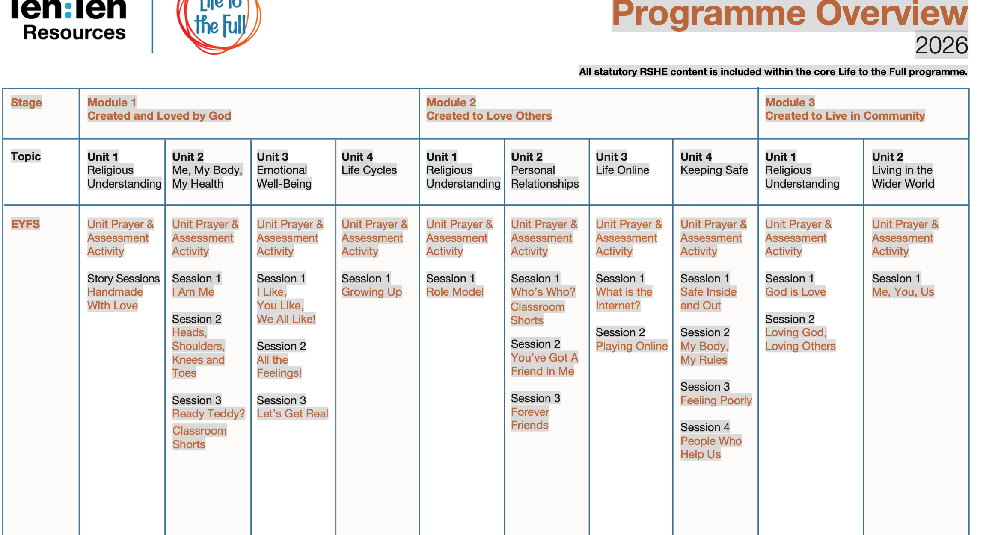

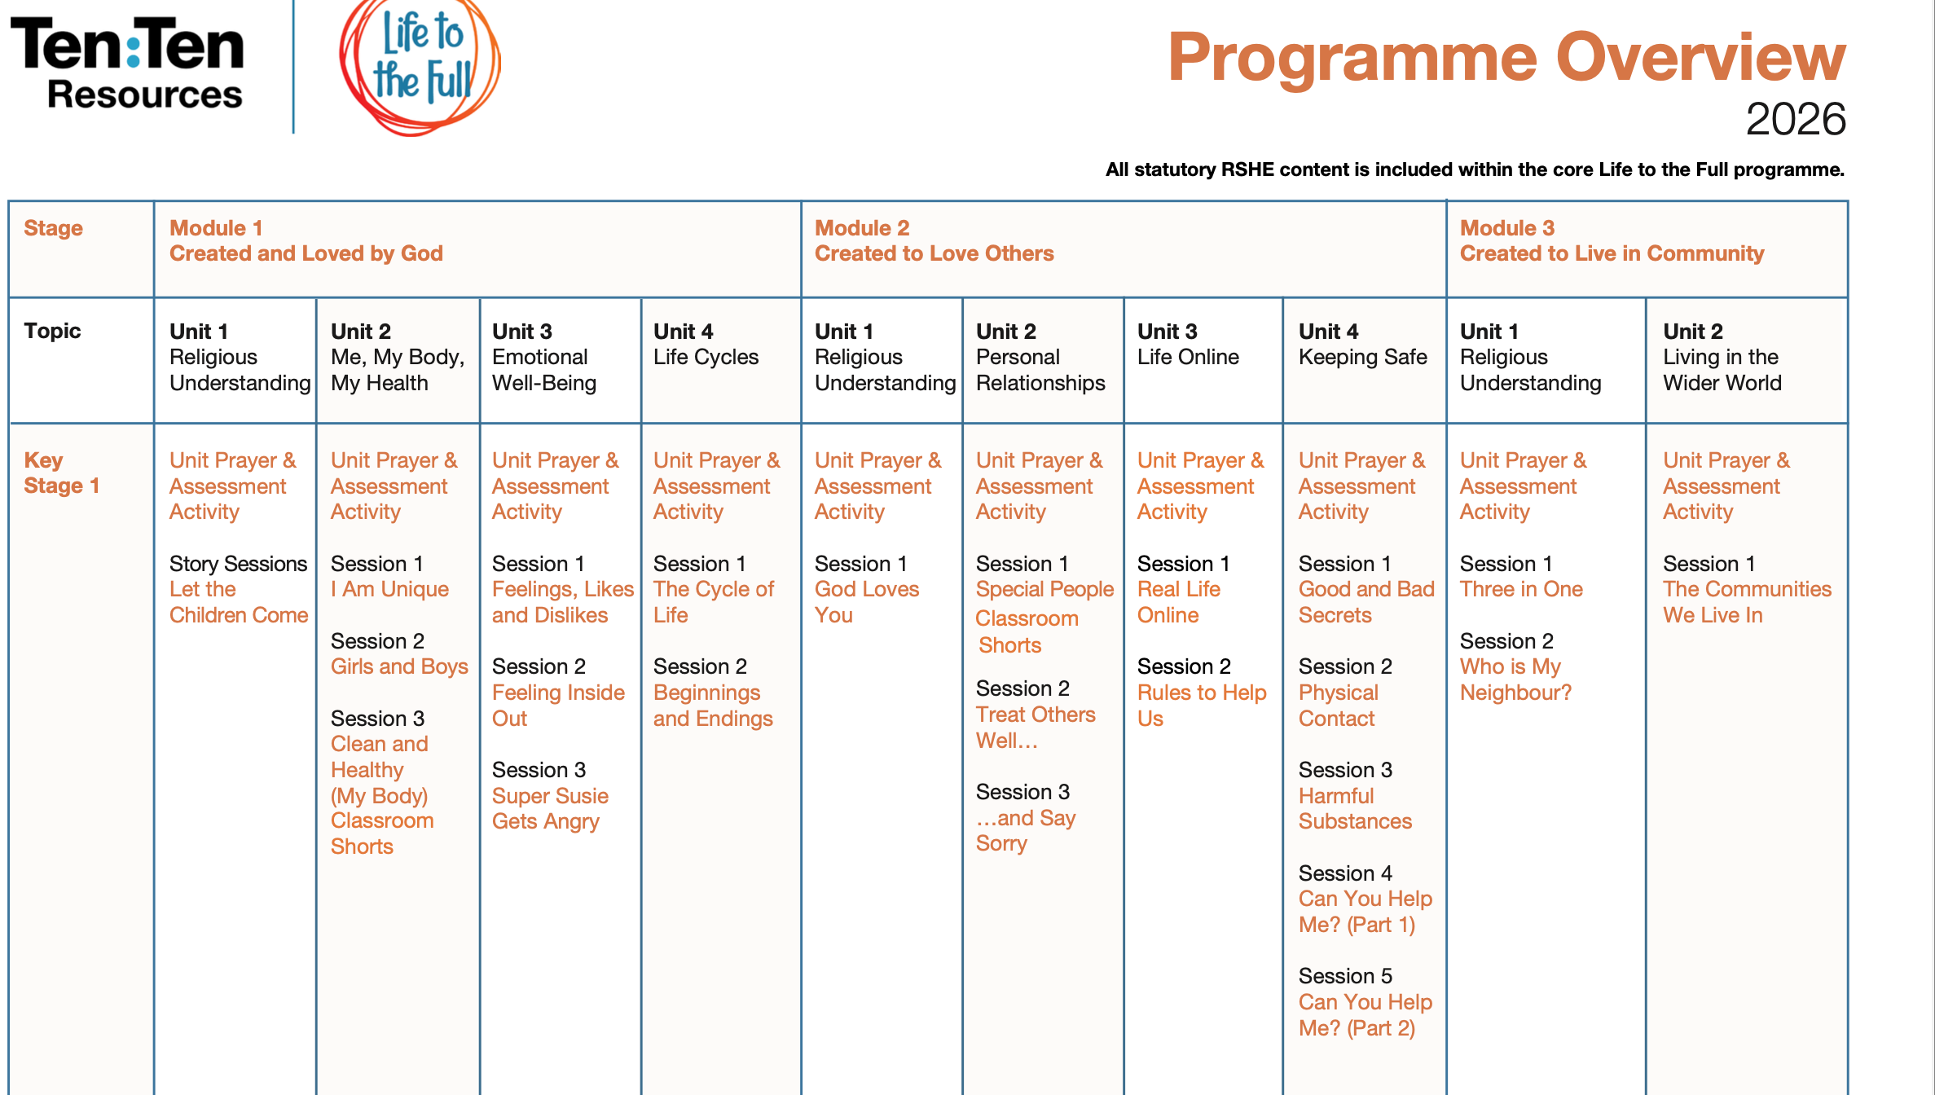

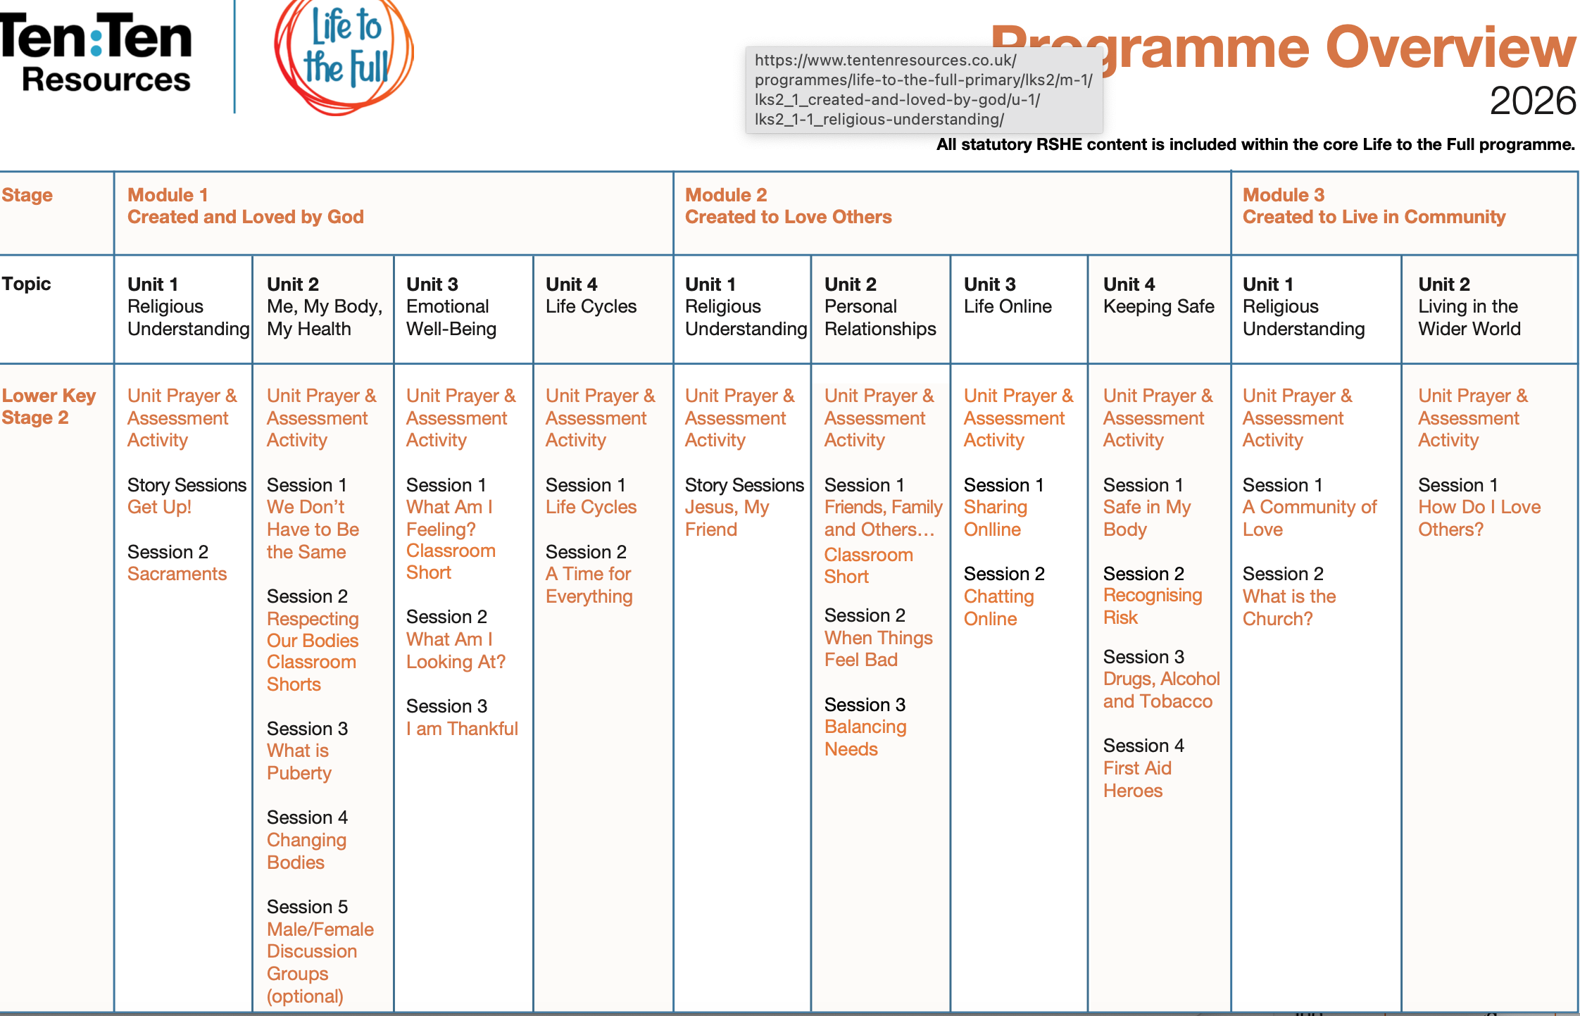
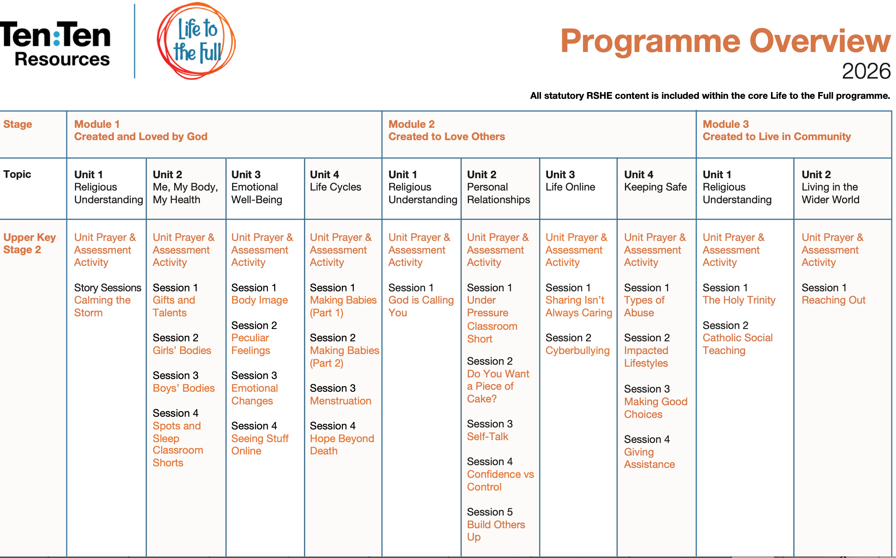

- Appendix B: Code of Practice for External Speakers


CHECKLIST FOR EXTERNAL SPEAKERS / ORGANISATIONS INVITED
TO SCHOOLS

In this checklist ‘School(s)’ means all Catholic school(s). For the avoidance of doubt this includes:
- Catholic voluntary aided schools;
- Catholic independent schools (including Catholic academies);
- Catholic sixth form colleges; and
- Catholic non-maintained special schools.
As an integral part of its educational vision for the holistic formation of children and young people, the Catholic Church expects Catholic schools to promote and uphold high standards throughout their activities and this includes visits from external speakers.
All external speakers invited to schools should be of the highest quality and school leaders are responsible for ensuring that they have enough information about the content to be delivered by any external speaker to enable them to determine whether the content will be pitched at the right level for the age and level of maturity of the children and young people to whom the external speakers will present. All schools should have clear policies for the booking of external speakers which includes sign-off of the booking at an appropriately senior level and compliance with safeguarding checks.
Schools should also be mindful of the DfE guidance on “political impartiality in schools” which can be found by following this link:
Political impartiality in schools - GOV.UK (www.gov.uk)
This checklist should be completed prior to welcoming (and establishing collaborative relationships with) external speakers (and any organisation they represent) to ensure that the Catholic character of your school is preserved and developed in the external speaker’s communications with pupils and parents and carers.

Name of Speaker

Question | Answer | Actions needed/Comment
Will the Speaker be supervised at all times during their visit?  If not, why not? | YES ☐  NO ☐  FURTHER COMMENT ☐
Have you carried out safeguarding checks (if appropriate) for the Speaker and have these been recorded in accordance with the school’s safeguarding procedures? | YES ☐  NO ☐  FURTHER  COMMENT ☐
Has the Speaker understood and confirmed that their communications in the school will:  - Be respectful towards Catholic teachings  - Not be prejudicial or detrimental to the Catholic character of the school  - Not engage pupils in political activity and  - Not cover certain partisan political views which are not deemed relevant or appropriate (provide details if applicable)  - Be delivered in accordance with the requirements set out in the DfE’s guidance on political impartiality in schools (if appropriate) | YES ☐  NO ☐  FURTHER  COMMENT ☐
Have you reviewed the resources/materials that will be used by the Speaker? | YES ☐  NO ☐  FURTHER  COMMENT ☐
Have you reviewed other resources produced by the Speaker (and by any organisation the speaker represents) even if they will not form part of the speaker’s activities at the school? | YES ☐  NO ☐  FURTHER  COMMENT ☐
Have you conducted a general internet search using the Speaker’s name (e.g. a google search)? If parents or children and young people conducted a similar search are any concerns likely to arise? | YES ☐  NO ☐  FURTHER  COMMENT ☐
Can you confirm that the political views espoused by the speaker/speaker’s organisation are in compliance with British values and do not involve taking an extreme political position? | YES ☐  NO ☐  FURTHER  COMMENT ☐
Have school policies and procedures applicable to the speaker been explained to and understood by the Speaker? | YES ☐  NO ☐  FURTHER  COMMENT ☐
Are there any other outstanding issues or concerns with the Speaker and/or their suitability? | YES ☐  NO ☐  FURTHER  COMMENT ☐
Will the Speaker deliver content of a high quality that is appropriate to the age and maturity of the children or young people in the audience? | YES ☐  NO ☐  FURTHER  COMMENT ☐

If you have any concerns regarding the suitability of this Speaker, you should contact your Diocese to seek further clarification.

Signed ___________________________
Position ___________________________
Dated _______________________

Approved for booking
Senior Staff member Name ___________________________
Position ___________________________
Dated _______________________

Relationships Education, Relationships and Sex Education (RSE) and Health Education: Statutory guidance for governing bodies, proprietors, head teachers, principals, senior leadership teams, teachers, July 2025, p.2
Gravissimum Educationis, 3
Relationships Education, Relationships and Sex Education (RSE) and Health Education: Statutory guidance for governing bodies, proprietors, head teachers, principals, senior leadership teams, teachers, July 2025, p.7
To Know You More Clearly, The Religious Education Directory for Catholic Schools, Academies and Colleges in England and Wales, 2022, CBCEW, p6.
CES Checklist for External Speakers to Schools, 2016
For the avoidance of doubt, the CES advises that the DfE guidance and this checklist should be followed by all of the specified educational settings listed above. This is the case, even where the DfE guidance does not apply to the setting type.

